**Capstone Design Final Report**

**RUMYPET**

**Mobile Application of Registering Dog’s Identification**

**Chung-Ang University, Capstone Design**

**Team Groza**

**Kim Tae Hong(20132335),**

**Kim Chan Il(20150577),**

**Paeng Jin Wook (20154645)**

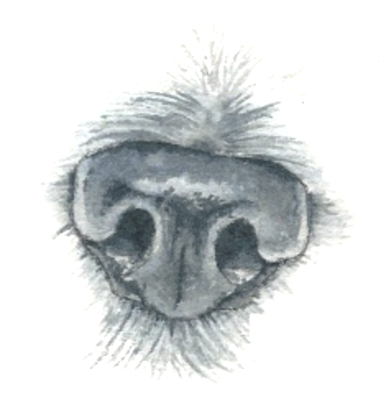

Index

1. Introduction2

2. Project Construction3

3. Development History5

4. Execution Explanation6

4-1. Main Page6

4-2. Sign up Page6

4-3. Sign in Page7

4-4. Dog information Page7

4-5. Register dog Page7

4-6. Detail information Page8

4-7. More detail information Page9

4-8. Find the dog Page 9

4-9. Process of the Python Code10

5. Performance Test12

6. Problems and solutions13

7. Impression15

**1. Introduction**

According to the statistics of ‘*Animal and Plant Quarantine Agency’* [1], 245 pet animals were abandoned on a daily basis in South Korea. Totally about 90,000 animals are abandoned or went missing last year in 2017, and this figure increased for the third consecutive year.

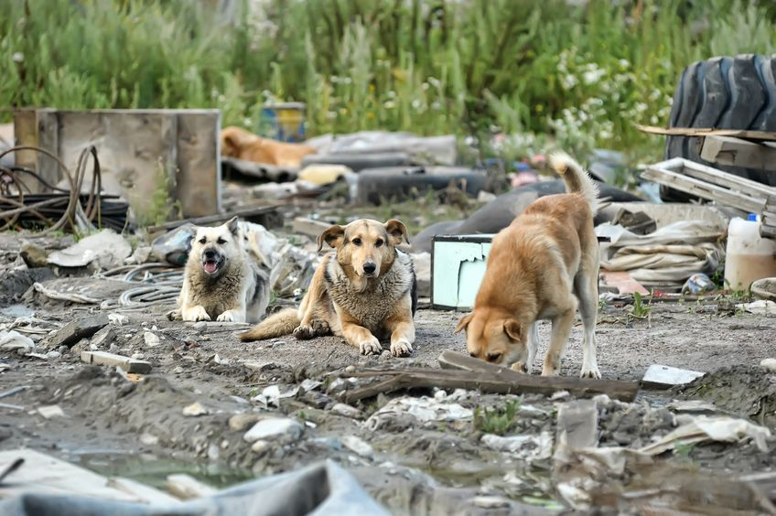Considering just over 90,000 animals were tagged with identification chips last year, around the same number of pet animals were abandoned as those that found a new family. (In Animal type, Dogs account for 70.9% of all abandoned pet.)

Only 30.4 percent of stray animals were adopted after entering a shelter, while 35 percent died a natural death. The data also said that only 15.2 percent of the stray animals were able to return to their owner.

Local governments also reported an increase in expenditures on animal shelters and the rescue and protection of stray animals, up 18 percent from last year while totaling around 11.5 billion won.

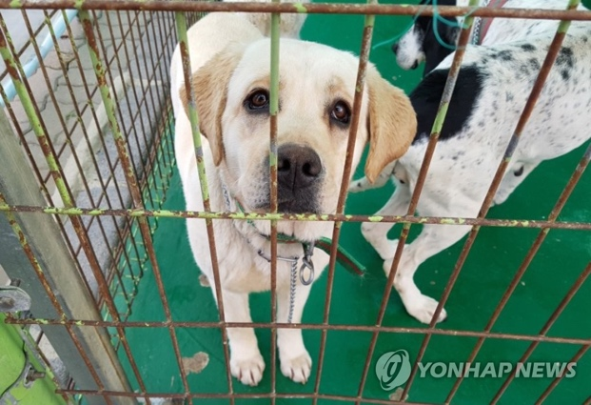Pet Ownership is on the rise in South Korea, as the dog population in the country exceeded one million for the first time last year, with over 5,500 people estimated to be working in the pet care industry. At the same time, the number of stray animals also grew in a serious way.

We thought this situation need some solutions to solve these big problems. Meanwhile, we found out that **Dog’s Nose shape is different for each dogs.** This has the same principle with fingerprint in human side. We though these facts could be applied to make identification to the dog. (We firstly considered in the side of the dog, because they account for most of the rate in the statistics)

So we decided to develop a **mobile application that can register dog’s identification using dog’s nose images.**

Functionally, we plan this application that user could access their dog’s private information with verification of the dog’s nose image and find the dog’s owner information with unknown dog’s nose images.

**2. Project Construction**

To develop our Application, we need Android application for user to use this application, Server to manage database of the user, dog, and images, and Python code in the server to process the Computer Vision work for image using OpenCV Library.

To use Computer Vision technology, we have to use python code using OpenCV but it cannot directly applied to the Android Application. So we used the cloud server Amazon Web Service, and using NoseJS, we planned to implement the python code through the server.

Our team, **Groza**, is consisted of three people.

So we divided our job into 3 Parts, **Android, Server, and Computer Vision.** And we controlled the Version using GitHub. Below is our GitHub page link.

https://github.com/GrozaTeam/Rumypet

We set our user case and design them using Sketch application in MacOS

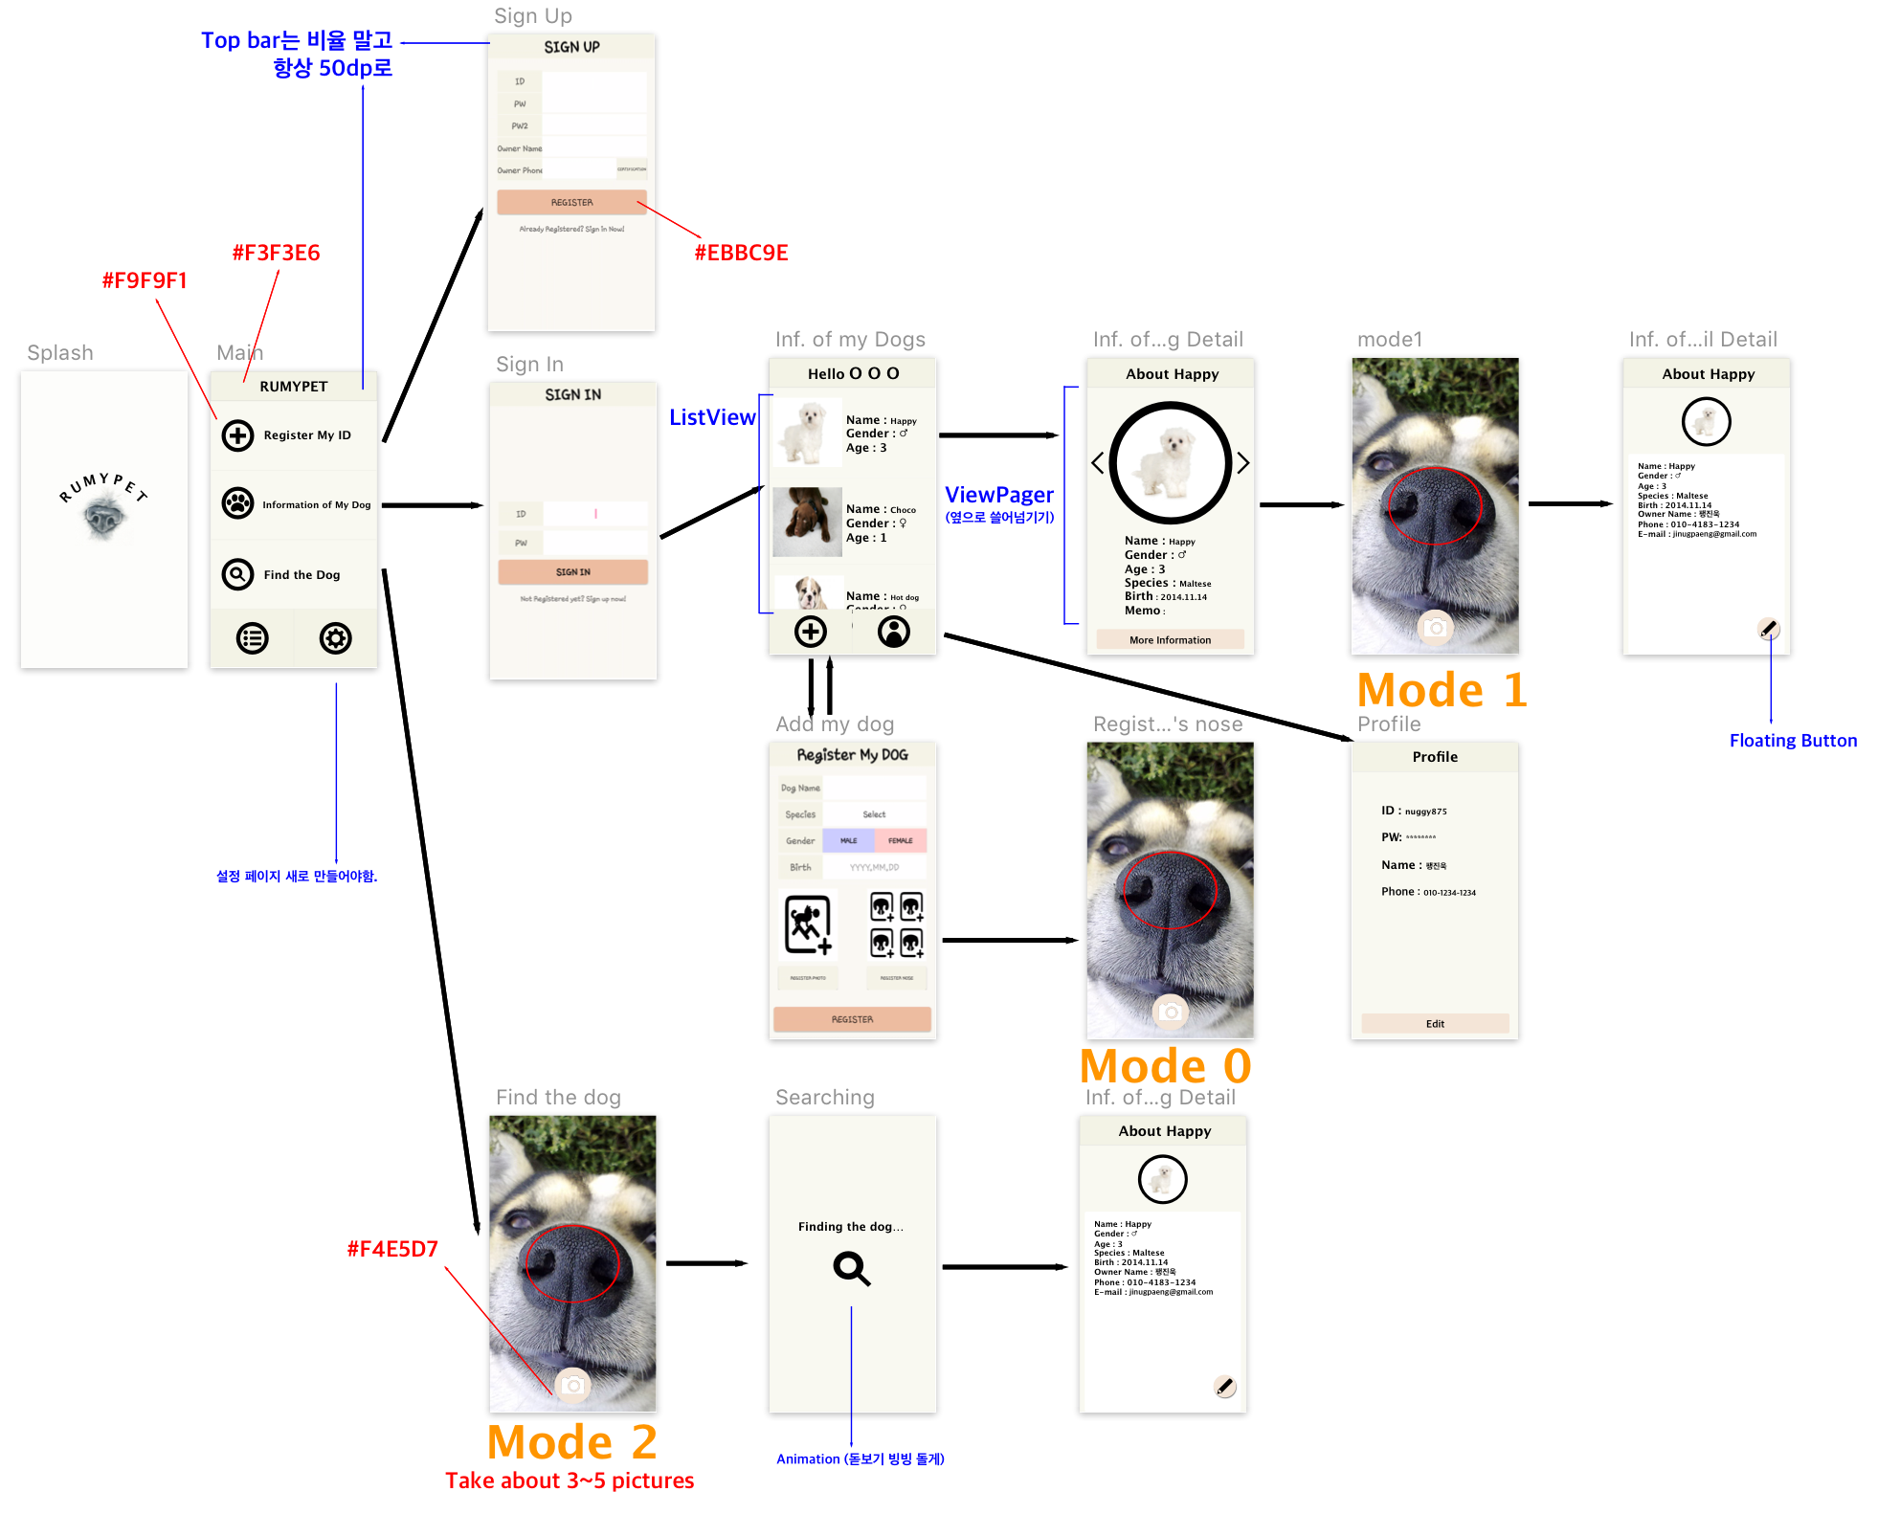

*<Figure1. User case and the design of Android Application using the application Sketch>*

Before we developed, as user case above, we had outlined our project flow into mainly three parts. Because each of them are different in using database, router, and so on.

In **Mode 0 (Registration)**, the applicationcan register the dog by just uploading the dog’s image and dog’s nose image.

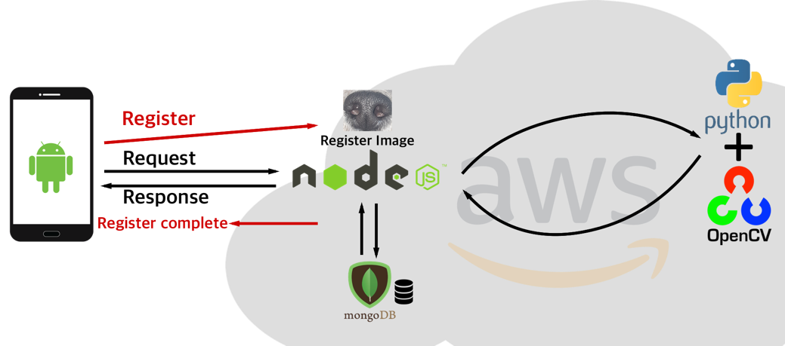

*<Figure1. Mode 0 Registration>*

In **Mode 1 (Verification),** the applicationcan verify the dog’s identity. User upload the image of the dog’s nose to the server and the python code in the server judge that the dog is the same dog with the registered dog. it returns true or false to the android application

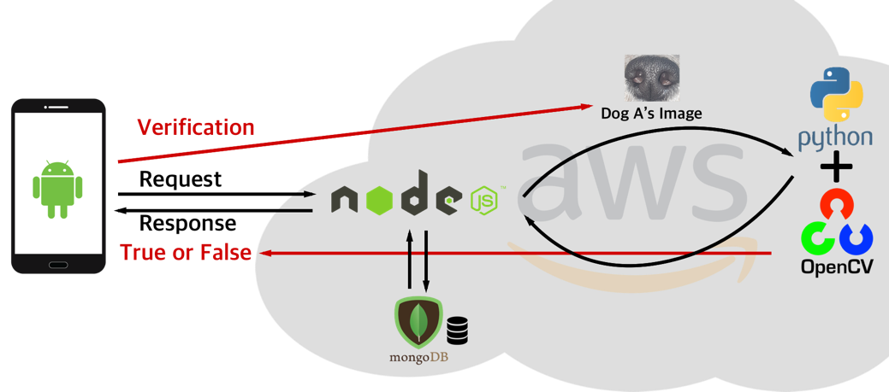

*<Figure2. Mode 1 Verification>*

In **Mode 2 (Identification),** the applicationcan let user know that whose dog it is. User upload the image of the dog’s nose to the server and the python code in the server compares all the data in the database, returns the comparing result, orders it by the result score, and make some candidates to let user to collect the dog from it.

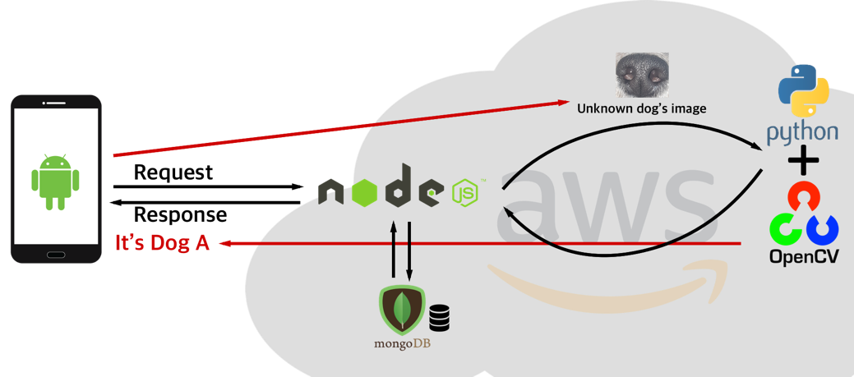

*<Figure4. Mode 2 Identification>*

**3. Development History**

To Develop our project, we need some dog’s nose data because we don’t have any. So we visited dog cafe near Hap-Jung Station to collect some datas of the dog’s nose.

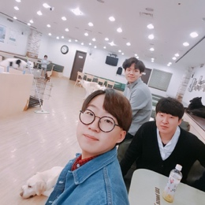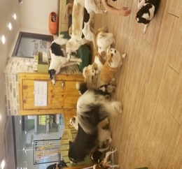

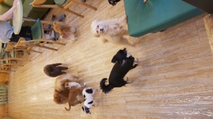

As a result, we collected some datas 10 kinds of dogs, 4~6 nose images per dogs, totally about 50 data which is high resolution.

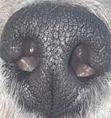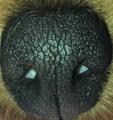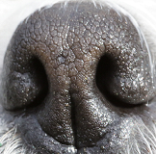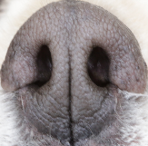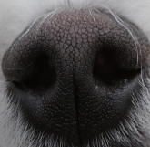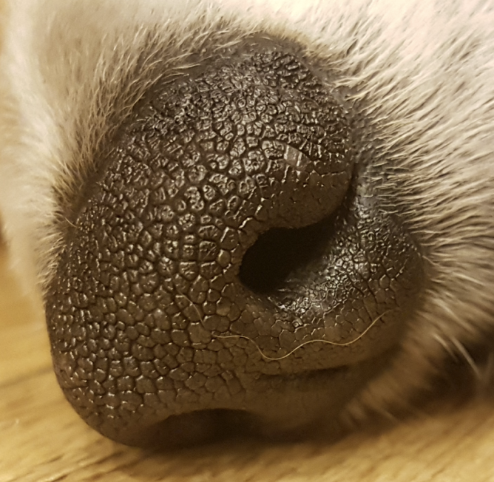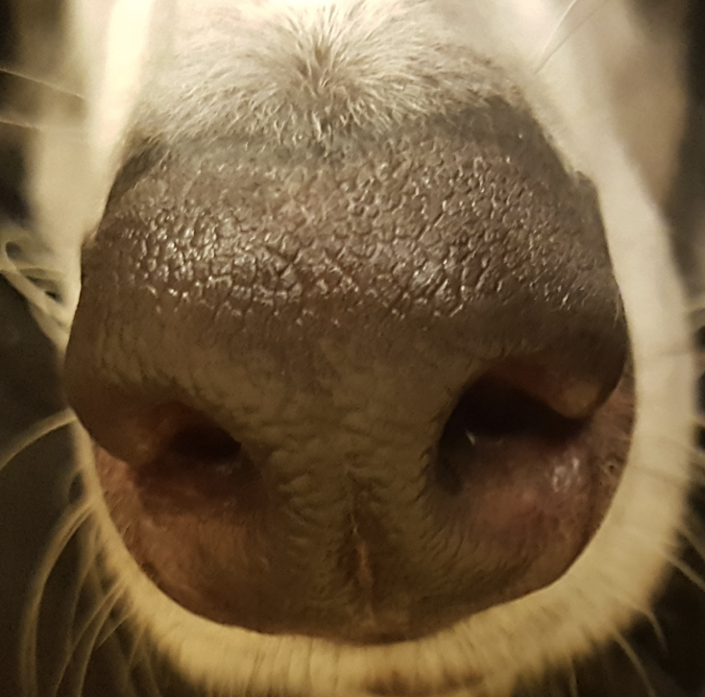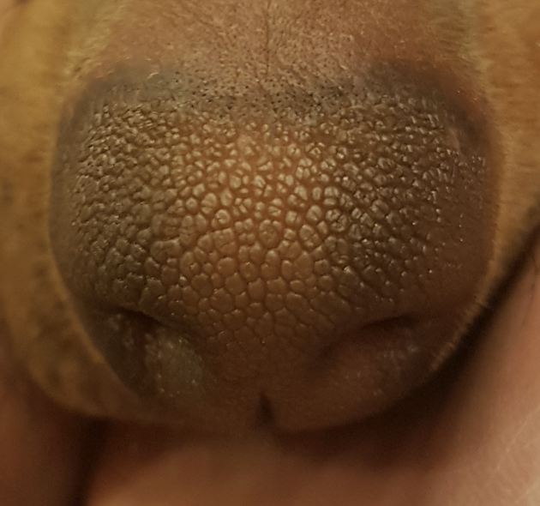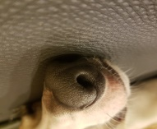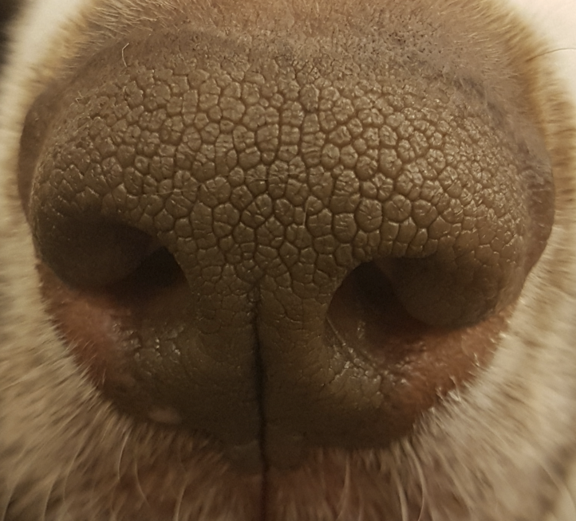

We used Sketch Tool for Designing the Android Application.

We used three programming languages (Java, JavaScript, Python) for this project



We controlled the version using GitHub. https://github.com/GrozaTeam/Rumypet

And we used Editor of Android Studio for Android(Java), ATOM for NodeJS(JavaScript), and PyCharm for Python(Computer Vision)



These are the **environment of our development**

*NodeJS version 8.11.2*

*npm version 5.6.0*

*Python version 3.6.5*

*Pip version 9.0.3*

*OpenCV_contrib version 3.4*

*Android Studio 3.1.3*

*compile Sdk Version 26*

*Amazon Web Server EC2 (Amazon Linux AMI)*

**4. Execution Explanation**

We will explain the execution process through the flow of user case (*Figure1*)

**1. Main Page**

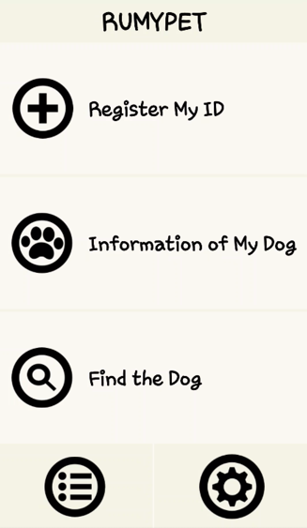We have mainly three buttons in main page.

User can register ID through first button “Register My ID”

*<Figure5. Main Page Layout>*

**2. Sign up Page**

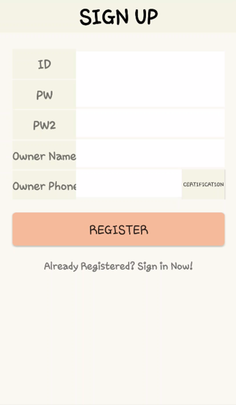User can Sign up ID with the information above. User information get authentication process through the server in NodeJS and upload in MongoDB database. The information goes through the router of */user/:id* in POST Method. Password would save as hashed String value because of the security.

We managed our data in MongoDB using Robo3T platform.

*<Figure6. Sign Up Layout>*

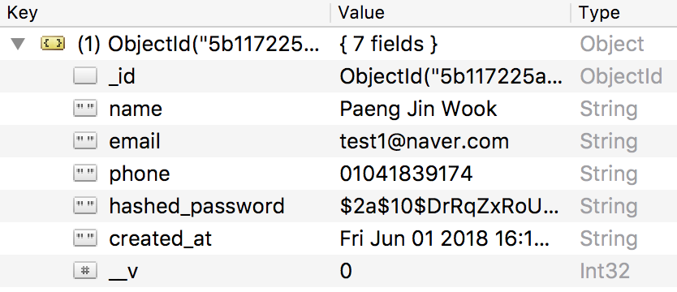

*<Figure7. User table in MongoDB >*

We used MongoDB which is NoSQL. It could be managed through JavaScript and easily combined with the NodeJS code which is also consisted of JavaScript Language.

We have 7 columns in the user table

**3. Sign in Page**

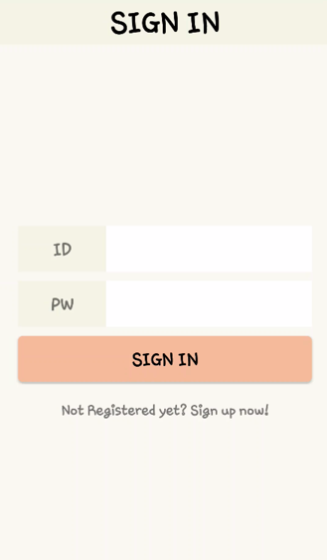User can Sign in with registered ID. This goes to the server router of */authentication* and will show user the information of user’s dogs.

If user input the wrong password or ID that is not exist, It refused to sign in.

*<Figure8. Sign In Layout>*

**4. Dog Information Page**

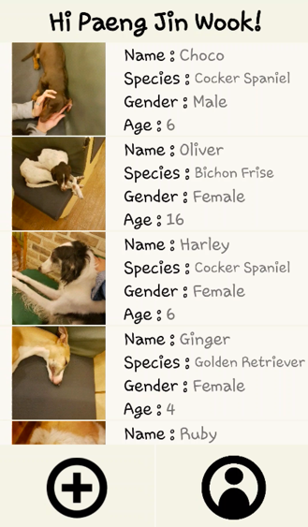Information of user’s dogs will shown by ListView in the center of above layout. The dog information comes in through the router of */dogs/:ownerId* in GET Method.

We used library ‘Glide’ to call image of each dog fast and safe.

User can add user’s dog through Plus (+) button at the bottom of the layout. And user can check their profile information through Profile button beside the Plus (+) button. Profile layout has nothing special (show user the profile and edit), so we will skip to explain about that.

*<Figure9. Dog Information Layout>*

**5. Register the dog Page**

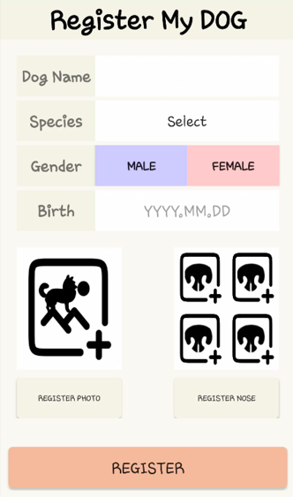User can register the dog with the information in the Figure10. (which is called **Mode 0**)

The dog’s information would upload through the router of */dogs* in Post Method.

User can set dog’s name, species, gender and birth. And user can upload dog’s picture which would be shown in the ListView of Dog Information Page. If user don’t upload the dog’s picture, the ListView will show user the default image of the dog. But it will later help other user to find user’s dog, so we recommend to upload it.

User have to upload three dog’s nose images which is the core of this application. User can upload this three images through the gallery user have or take a video for 5 seconds.

The video will be uploaded to server and processed by python code. Python code will extract 3 images which is high resolution from the video and save them in the local database in AWS server.

*<Figure10. Register dog Layout>*

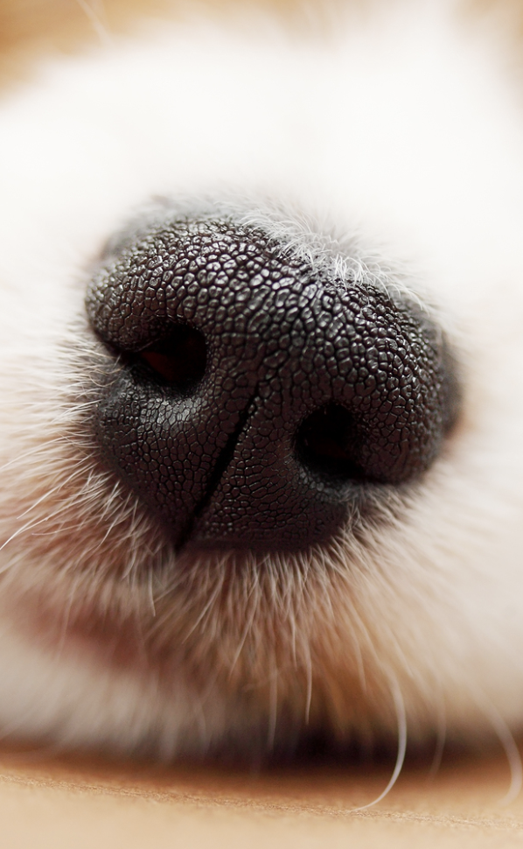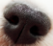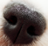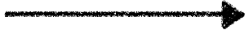

*<Figure11. Uploading pictures through recording video>*

When user register the dog, the information of the dogs are saved in MongoDB.

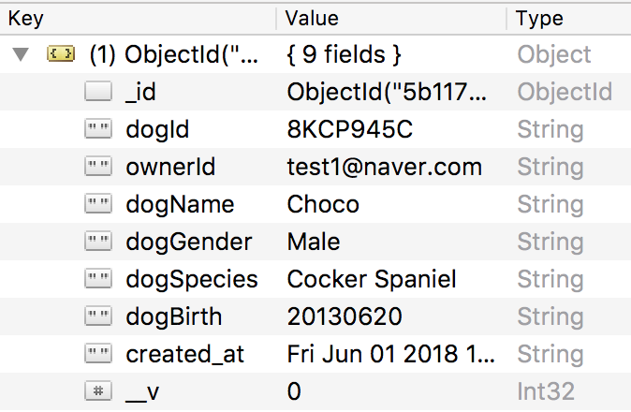

*<Figure12. Dog table in MongoDB>*

Dog table have a column of dogID, ownerID, name, gender, species, and birth.

dogID is created by random string in length 8.

And the images are saved in Local Storage in Server AWS by Dog ID.

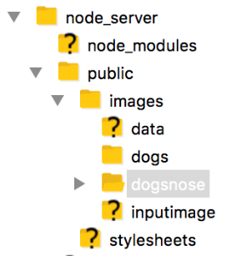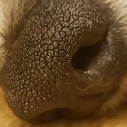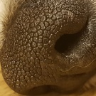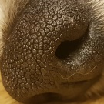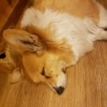

*<Figure13. Dog images in local storage of server>*

When Registering process terminate completely (by press Register button at the bottom of the page), ListView in the Dog information Page add this dog’s information.

**6. Detail Information of the dog**

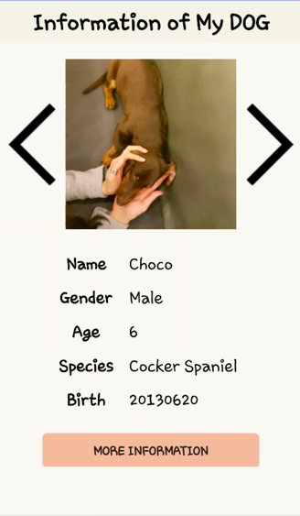User can see the detail information of one dog with clicking one of the item in the ListView in *Figure9*.

User can see other dog’s information easily through left/right arrow.

But this information is limited, and if user want to see more detail information which is private, user have to get verification through dog’s nose image (which is called **Mode1**)

User can get verification through the button at the bottom of the image.

*<Figure14. Detail Information Layout>*

**7. More Detail Information of the dog**

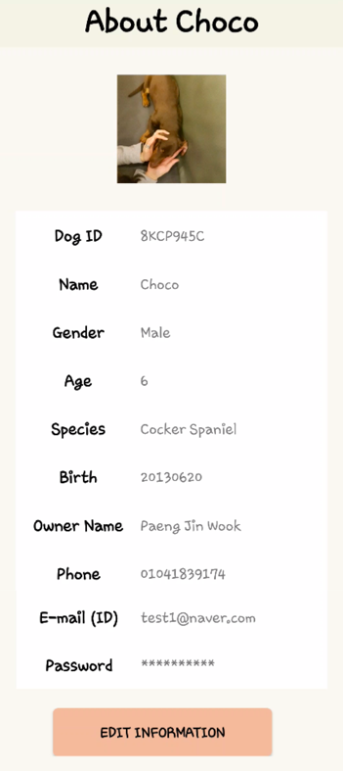After Verification process from the Python (**Mode1**), more information about chosen dog comes out. User can edit their dog’s information here.

If verification process returns ‘false’, the application shows ‘verification failed’ message and can’t come to this page.

We will explain the principle of Verification process later in this report.

The information also gets from the server through the router in GET Method.

*<Figure15. More Detail Information Layout>*

**8. Find the dog (Mode 2)**

Next, we will expalin about the last button in the Main Page (*Figure 5*)

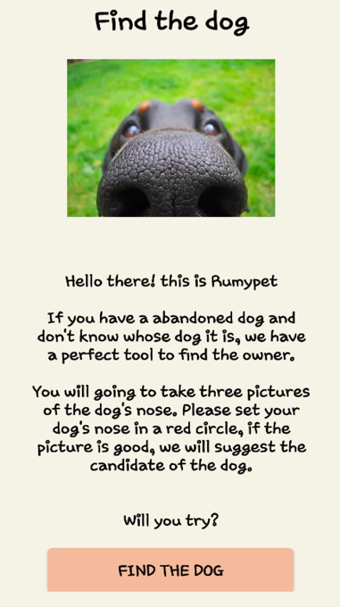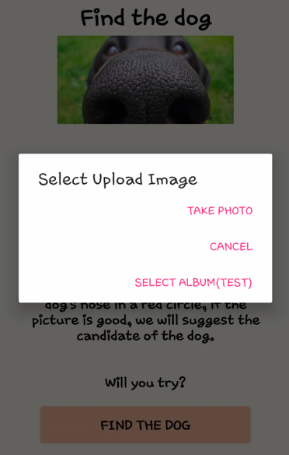

When user click it, this page comes out and explain about this function.

When user click ‘Find the dog’ button in the bottom of the page, this application will require user for the image or the video.

When user click ‘Take photo’ button, it will be ready to record the dog’s nose for 5 seconds

When user click ‘Select Album’ button, it will show user’s gallery to select the dog’s nose image.

*<Figure16. Find the dog layout>*

After finding process, the application will show you the candidate of the dog ordered by the matching score from the python code in the server.

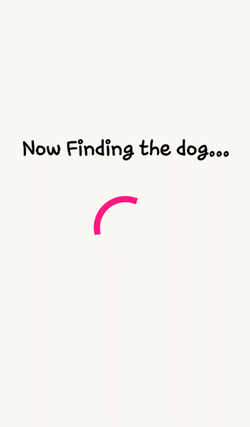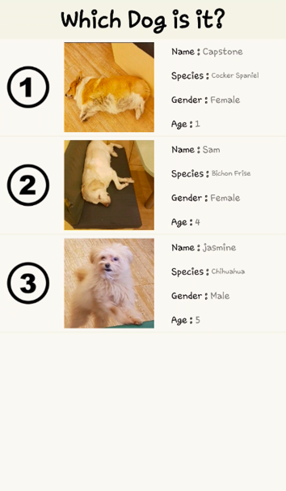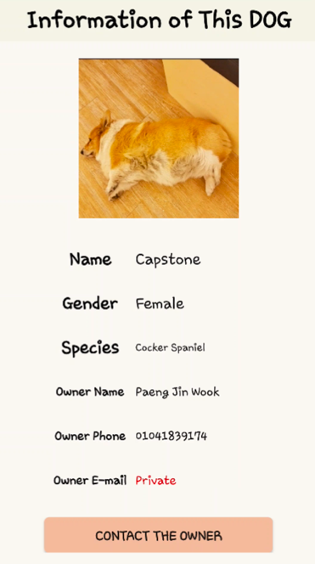

User can check out the owner’s information by clicking one of the candidate in the page.

User can set whether they will open their phone number and e-mail or keep them private.

*<Figure17. Find the dog layout 2>*

The return value of the python code is like below.



I means “dogId1 **:** dogId1’s score **/** dogId2 **:** dogId2’s score / dogId3 **:** dogId3’s score …”

It is the ordered value by the python code.

With this process, user can find out the unknown dog’s owner easily with the dog’s nose image.

**9. Process of the python code (Mode1 and Mode2)**

In Mode1 (verification) and Mode2 (Identification), we used python code which use the OpenCV library that can return the matching score of two image.

The process is largely consist of two stages. **Pre-processing method**, and **Feature Matching method**

**9****-1. Pre-processing Method**

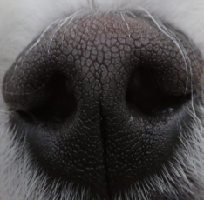

**Cropping**

**Gray Scaling**

**Equalization**

**Gabor-Filter**

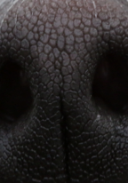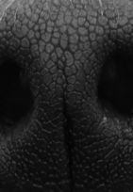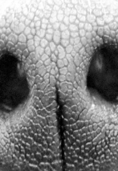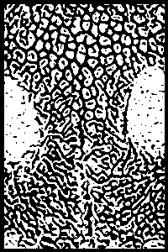

*<Figure18. Pre-processing Method>*

The Pre-processing Method is consist of the process in *Figure18*. For the situation that the input image has a distortion of brightness, saturation or something else, we used Gabor-filter to ignore this and extract the exact line in the nose of the dog. This process is also used in the fingerprint recognition Algorithm.

**9-2. Feature Matching Method**

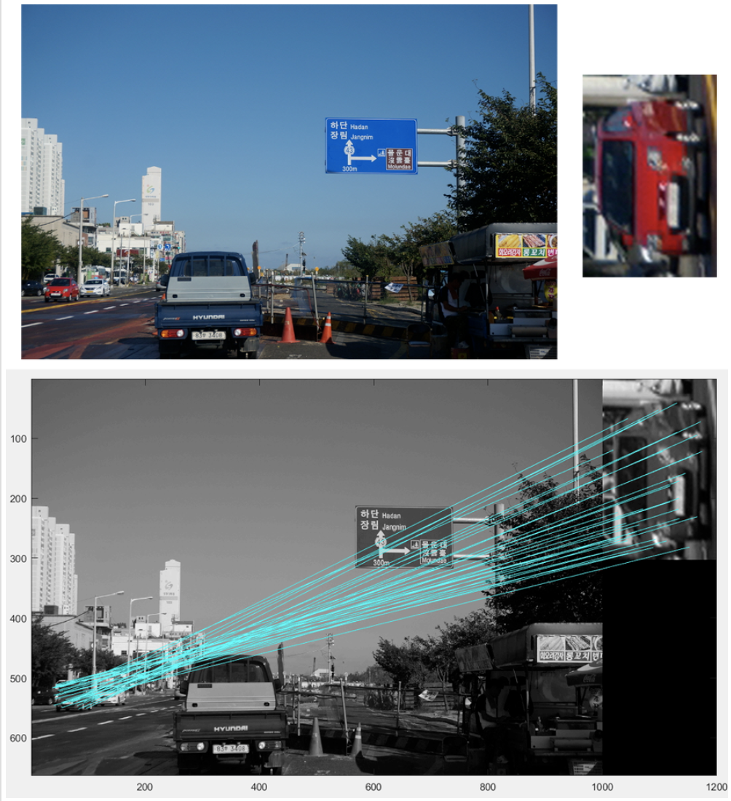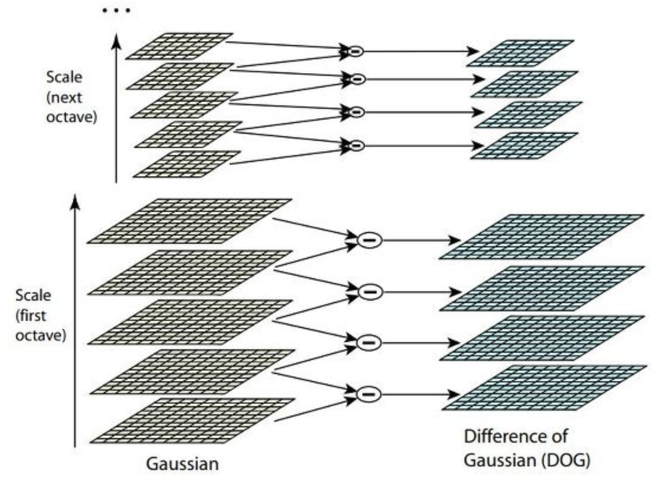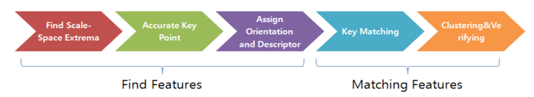

*<Figure18. Principle for SIFT Matching Algorithm>*

We used SIFT Matching Algorithm for feature matching.

This process have a stage of below.

1. Make Scale Space
2. Calculate DoG (Difference of Gaussian)
3. Find Key points
4. Remove bad Key points
5. Assign direction to each Key points.
6. Finally, get the Features of the image.

Firstly it extract the Scale space from the image. It consist of several images that have various scale.

With using difference of Gaussian from the Scale Space, It can find the key point (which is called features) from the image. After remove the bad Key points, it assign the direction to each good key points and finally get the features of the image.

And then it compare two image’s features and get the score of two image.

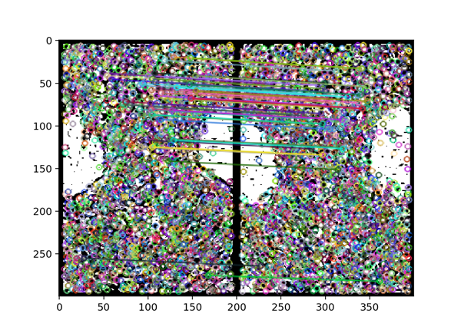

We tried various of Matching Algorithm.

SURF Matching is fast and mostly used in fingerprint algorithm. But it’s performance is worse than SIFT Matching in terms of dog’s nose images.

And we find out that ORB Matching is not suitable for dog’s nose images through testing. (have worse score and speed)

*<Figure19. Process of SIFT Matching of two dog’s nose image>*

**5. Performance Test**

We had a lot of performance tests while using the application and we make document for the performance. We upload it in google document and below is the link.

https://docs.google.com/document/d/1pL2lyfOHulheafOweTAL9tyVRuBzS5TEP3y567xYINU/edit?usp=sharing

Here in the report, we will summarize the core of the performance test

**Performance Test Environment**

*Mac OSX High Sierra 10.13.3*

*Processor 2.3 GHz Intel Core i5*

*Memory 8GB 2133 MHz LPDDR3*

*Grapic Intel Iris Plus Graphics 640 1536 MB*

*Python 3.6.5*

*OpenCV 3.4.0*

**Performance Test Result**

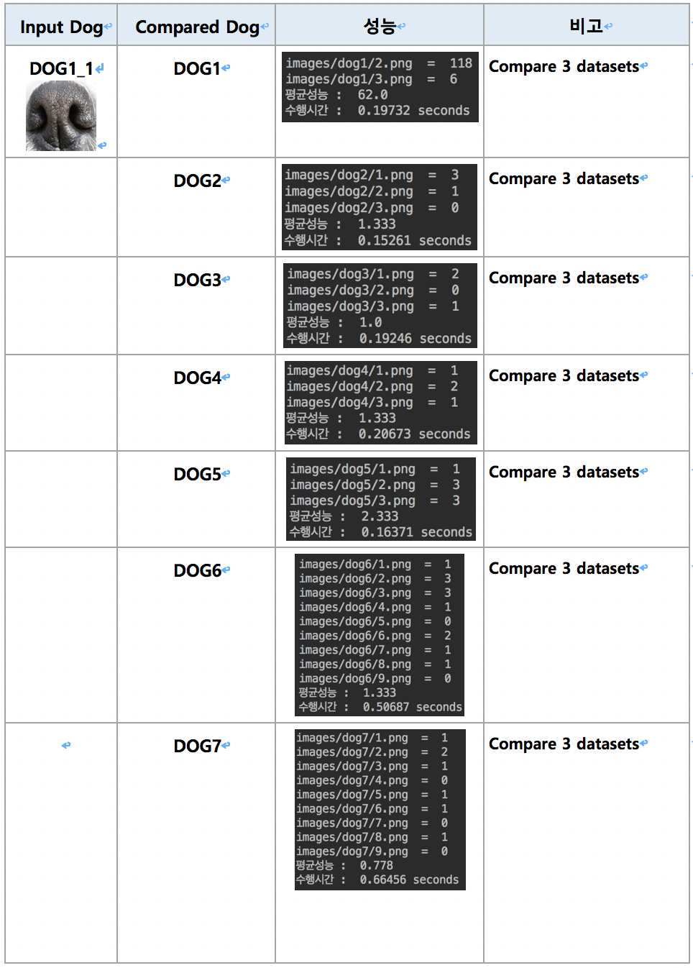

*<Figure20. Performance Test Result>*

**Performance Test Explanation**

We show the performance result of one dog in this report.

As in the table, the matching score comes out more than 50 in average for the same dog’s nose image.

The matching score comes out lower than 10 in average for the different dog’s nose image.

So we used value ‘50’ for the android application, and find out it works well.

**6. Problems and Solutions**

Of course it works well, but the project have some problems when it is commercialized.

**1. Performance Time**

In Mode 1, the python code compares the input image with only three images in the database. So the performance time is not a problem for verification.

But in Mode 2, Identification mode, the python code compares all the data from the local database in the server. We have about 50 nose data now in the database and it takes about 15 seconds to compare all of it in average, but when the application commercialized, the matching algorithm will take much more time and the user maybe won’t like it.

Maybe there will be no or very little more progress in the algorthm of pre-processing and feature-mathcing in terms of performance time.

So, to commercialize this application, we need some classification process of the dog with the dog’s species, colors, or something else. It could save much more time to compare the data from the server.

**2. Amount of data**

We currently have about 50 nose datas in the database. 4 to 6 nose image per 10 kinds of dogs.

When this project is commercialized, there will have many exception in implementation of the application. To considering and testing for more exceptions, it must have much more data.

About 10 more kinds of dog’s nose data will not help. It must have more than about 100 dog’s nose data in various situation in 100 or more kinds of dogs.

But we don’t have that much dog and we can’t collect them from the internet, because it must be a high resolution image which takes fully the nose of the dog.

So, to commercialize this project, we must take some supports from the enterprise related to pet, dog, or something else.

**7. Impression**

**Kim Tae Hong** : It was really rewarding for this semester. Especially, our team members suffered a lot. I really appreciate for them. I love you guys.

**Kim Chan Il** : Our team's project was too hard to connect each parts (Server / Android / Python), So we had many problems when we try to solve it. But, we tried hard and succeed. When it was solved, it gave satisfactions to our team.

**Paeng Jin Wook** : We all love dogs and consider so much how can we make this project help to solve the problem of the abandoned dogs. We aimed to commercialize it in the start of the project. In conclusion, the project need more things to commercialize, but I saw a possibility of this project. It was a good opportunity to improve developing skills in computer vision, and understand the current situation of abandoned, stray pets. If we can, I hope to develop the project more and commercial it to many users.